Step 1: Assign IP Addresses
R1
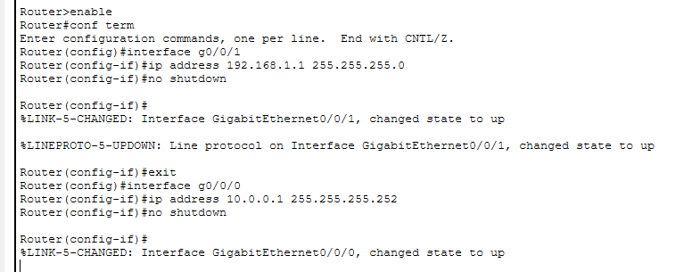
R2
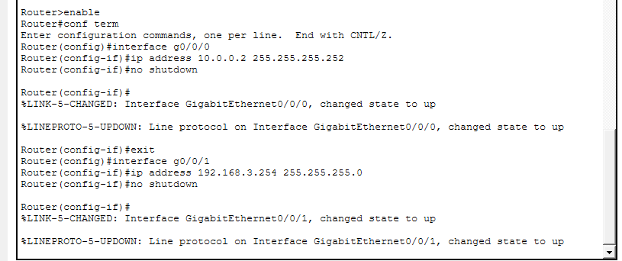

Step 2: Enable OSPF
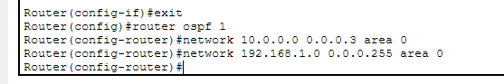
R2
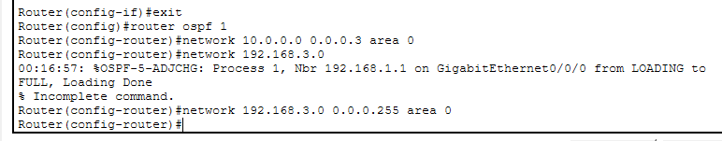
Step 3: Verify Neighbor Relationships
Show ip ospf neighbor
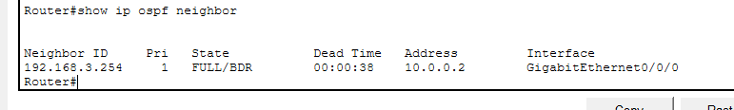
Show ip route
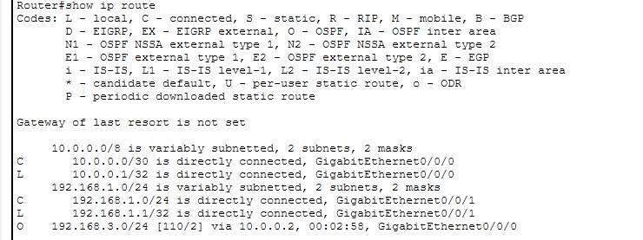

Test Connectivity
Ping 192.168.3.1
